***Chemistry***

**7: Chemical Bonding and Molecular Structure**

**7.5: Strengths of Ionic and Covalent Bonds**

65. Using the bond energies in Table 7.3, determine the approximate enthalpy change for each of the following reactions:

(a) 

(b) 

(c) 

Solution

(a) ;

(b) ;

(c) 

67. When a molecule can form two different structures, the structure with the stronger bonds is usually the more stable form. Use bond energies to predict the correct structure of the hydroxylamine molecule:

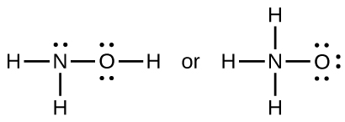

Solution

(a) ; (b) ; the greater bond energy is for (a), and it is more stable

69. Using the standard enthalpy of formation data in Appendix G, show how can the standard enthalpy of formation of HCl(*g*) can be used to determine the bond energy.

Solution



71. Using the standard enthalpy of formation data in Appendix G, determine which bond is stronger: the S–F bond in SF4(*g*) or in SF6(*g*)?

Solution





Proceeding in the same manner,. The 6F(*g*) and S(*g*) contribute 755.21 kJ; then  and  per mole of bonds. The S–F bond in SF4 is stronger.

73. Complete the following Lewis structure by adding bonds (not atoms), and then indicate the longest bond:

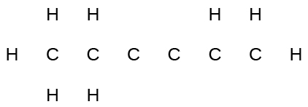

Solution

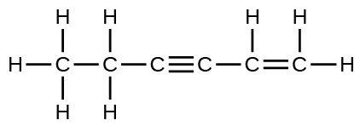

The C–C single bonds are longest.

75. Use principles of atomic structure to answer each of the following:[1]

(a) The radius of the Ca atom is 197 pm; the radius of the Ca2+ ion is 99 pm. Account for the difference.

(b) The lattice energy of CaO(s) is –3460 kJ/mol; the lattice energy of K2O is –2240 kJ/mol. Account for the difference.

(c) Given these ionization values, explain the difference between Ca and K with regard to their first and second ionization energies.

|  |  |  |
| --- | --- | --- |
| Element | First Ionization Energy (kJ/mol) | Second Ionization Energy (kJ/mol) |
| K | 419 | 3050 |
| Ca | 590 | 1140 |

(d) The first ionization energy of Mg is 738 kJ/mol and that of Al is 578 kJ/mol. Account for this difference.

Solution

(a) When two electrons are removed from the valence shell, the Ca radius loses the outermost energy level and reverts to the lower *n* = 3 level, which is much smaller in radius.

(b) The +2 charge on calcium pulls the oxygen much closer compared with K, thereby increasing the lattice energy relative to a less charged ion.

(c) Removal of the 4*s* electron in Ca requires more energy than removal of the 4*s* electron in K, because of the stronger attraction of the nucleus and the extra energy required to break the pairing of the electrons. The second ionization energy for K requires that an electron be removed from a lower energy level, where the attraction is much stronger from the nucleus for the electron. In addition, energy is required to unpair two electrons in a full orbital. For Ca, the second ionization potential requires removing only a lone electron in the exposed outer energy level.

(d) In Al, the removed electron is relatively unprotected and unpaired in a *p* orbital. The higher energy for Mg mainly reflects the unpairing of the 2*s* electron.

77. For which of the following substances is the least energy required to convert one mole of the solid into separate ions?

(a) MgO

(b) SrO

(c) KF

(d) CsF

(e) MgF2

Solution

The lattice energy, *U*, is the energy required to convert the solid into separate ions. *U* may be calculated from the Born-Haber cycle.

The values in kJ/mol are approximately (a) 3791; (b) 3223; (c) 821; (d) 740; and (e) 2957.

The answer is (d), which requires about 740 kJ/mol.

79. The lattice energy of LiF is 1023 kJ/mol, and the Li–F distance is 201 pm. MgO crystallizes in the same structure as LiF but with a Mg–O distance of 205 pm. Which of the following values most closely approximates the lattice energy of MgO: 256 kJ/mol, 512 kJ/mol, 1023 kJ/mol, 2046 kJ/mol, or 4090 kJ/mol? Explain your choice.

Solution

4008 kJ/mol; both ions in MgO have twice the charge of the ions in LiF; the bond length is very similar and both have the same structure; a quadrupling of the energy is expected based on the equation for lattice energy

81. Which compound in each of the following pairs has the larger lattice energy? Note: Ba2+ and

K+ have similar radii; S2– and Cl– have similar radii. Explain your choices.

(a) K2O or Na2O

(b) K2S or BaS

(c) KCl or BaS

(d) BaS or BaCl2

Solution

(a) Na2O; Na+ has a smaller radius than K+; (b) BaS; Ba has a larger charge than K; (c) BaS; Ba and S have larger charges; (d) BaS; S has a larger charge

83. Which of the following compounds requires the most energy to convert one mole of the solid into separate ions?

(a) K2S

(b) K2O

(c) CaS

(d) Cs2S

(e) CaO

Solution

CaO

This resource file is copyright 2015, Rice University. All Rights Reserved.

1. This question is taken from the Chemistry Advanced Placement Examination and is used with the permission of the Educational Testing Service.